NCR Cash Remittance



Contents

1. Introduction 4

2. Remittance Flows 5

2.1 Card-less to card-less 5

2.1.1 Description 5

2.1.2 Deposit Flow 6

2.1.3 Withdrawal Flow 8

2.1.4 Redemption Flow 10

2.2 Card based to card less 11

2.2.1 Description 11

2.2.2 Flow 11

3. Business Validations 12

4. Security Considerations 12

5. Settlement and Reconsolidation Process 13

4. Web Portal Application 14

4.1 Description 14

4.2 Functions 14

4.2.1 ATM Management 14

4.2.2 Transactions Handling 14

4.2.3 User Management 14

4.2.4 Customer Management 14

4.2.5 Reports 15

4.2.6 Bulk Transactions Reports 15

5. Alerting Service 18

5.1 Introduction 18

5.2 Architecture 19

5.3 Functionality 19

5.4 Alerting Service Main Points 19

5.5 SMS Contents 20

5.5.1 Deposit 20

5.5.2 Withdrawal 21

6. Hardware Requirements 22

6.1 Application Sever/Database Server/Gateway 22

6.1.1 Production Environment 22

6.1.2 Testing Environment 22

6.2 ATM 22

6.2.1 Hardware Requirements 22

6.2.2 Software Requirements 22

7. System Architecture 23

8. Financial Proposal 24

# 1. Introduction

People are constantly doing money transfer operations on a daily basis, whether it is lending money to someone else, transferring money outside of the country, one time only transfers and any remote money transferring in general. It has become a very big aspect in our everyday lives.

NCR Cash Remittance is a service provided by NCR that gives the bank customers an easy and ideal way of transferring money to other people through the well-established internal bank network, which is enhanced by the bank’s network policies and rules. It is also a good revenue boost for the bank since they get a fee for each transaction committed using this service.

All the customer needs to do is to interact with one of the bank’s ATM. The ATM needs to have this service previously installed. The customers will easily get a grip of utilizing this tool due to its user friendliness and clear instructions which appear on the ATM screen. The only requirement for the customer to have access to this service is to have his/her number registered in the bank’s system. This helps ensuring that they will receive vital information about the money transfer transaction they just conducted. This information includes ID of the transaction, their own personal PIN code (which would be used during withdrawal) and date of interaction. This information is a way of enhancing the security of the transaction and to ensure the transfer integrity. When a person deposits money for transfer in the ATM, the beneficiary client will also receive a SMS notifying them about the transfer. The SMS sent to the beneficiary also includes another PIN code (beneficiary PIN code). When the beneficiary client wishes to withdraw the transferred amount, he will need both his own PIN code and the depositor PIN code along with the transaction ID to commit a successful transfer.

All these operations are managed by a Cash Remittance Server which stores all the information about the transactions. The remittance server also is responsible for creating and managing the PIN codes for withdrawal and creating the SMS messages that will be sent to the depositor and the recipient.

This document aims to highlight some further details about the service including architecture, server details and requirements, available features of the application, portal application and the possible scenarios and flows involving this service including card based and card-less remittance transactions.

# 2. Remittance Flows

Part of the configuration of the Remittance Server is the selection of the Remittance flows to be implemented. Based on the flow selected there might be additional configurations and integration that will be required with the Banks own systems. These integrations are highlighted under each flow that is analyzed below.

## 2.1 Card-less to card-less

### 2.1.1 Description

This flow allows the user to make money transfers through the ATM without the need of using an ATM card or needing a bank account. All what is required is the mobile number to be registered on the system. The registered client will be able to deposit money into the ATM and will receive data about the transaction as stated earlier in the document. The following figure is a simple representation of the process:

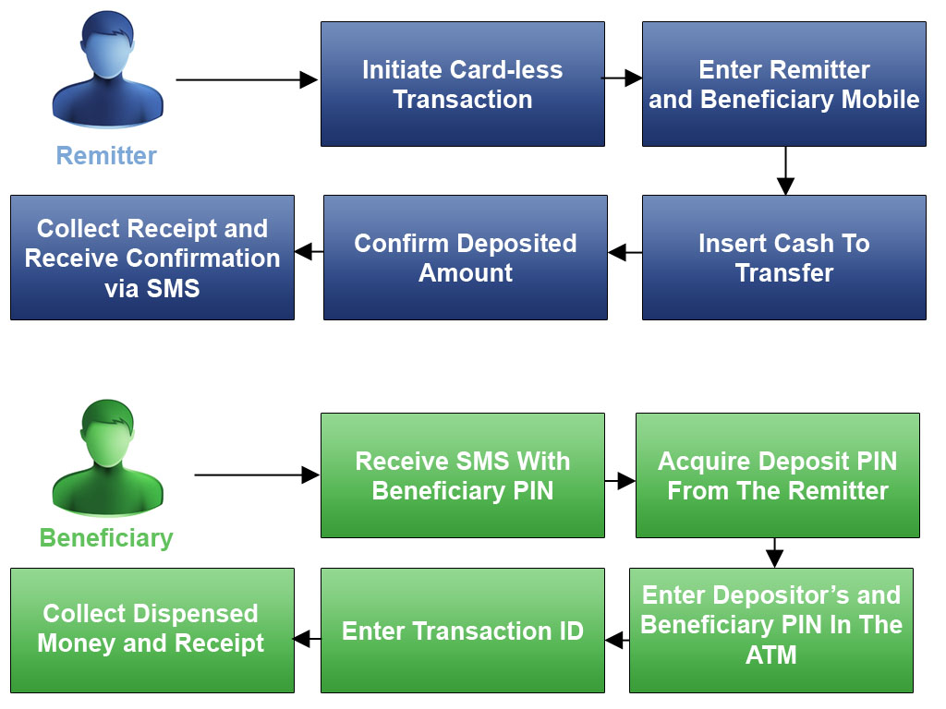

### 2.1.2 Deposit Flow

#### Deposit flow through an ATM

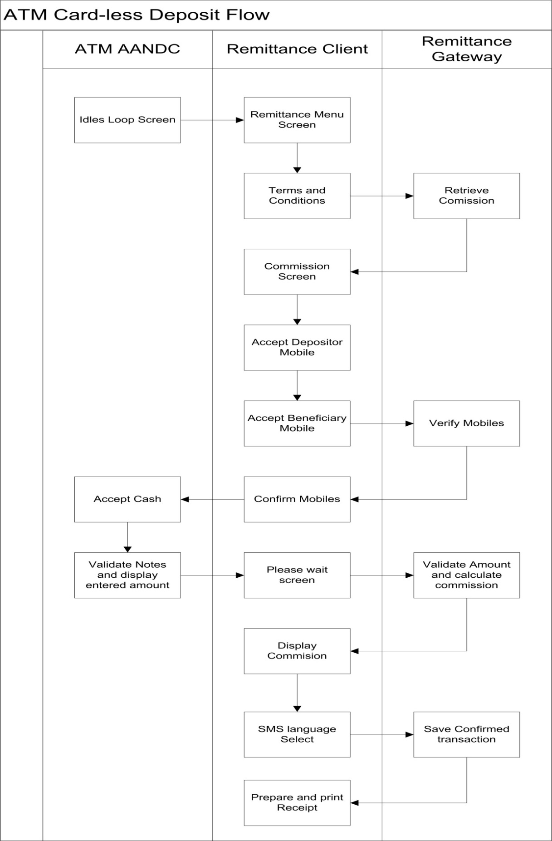

#### Deposit flow through branch

This flow is an alternative for the customers to utilize the remittance service without the need of an ATM machine. This is achieved by interacting with the branch directly and its employees.

The following figure illustrates how a transaction committed through the branch occurs:

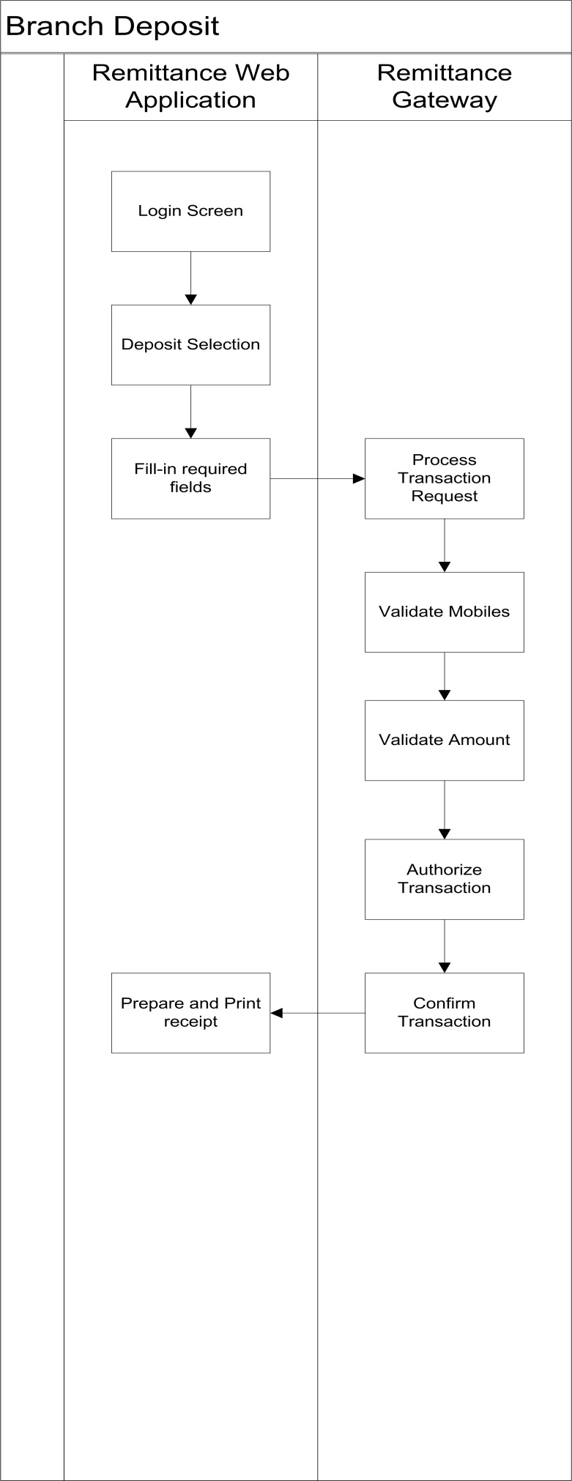

### 2.1.3 Withdrawal Flow

#### Withdrawal through an ATM

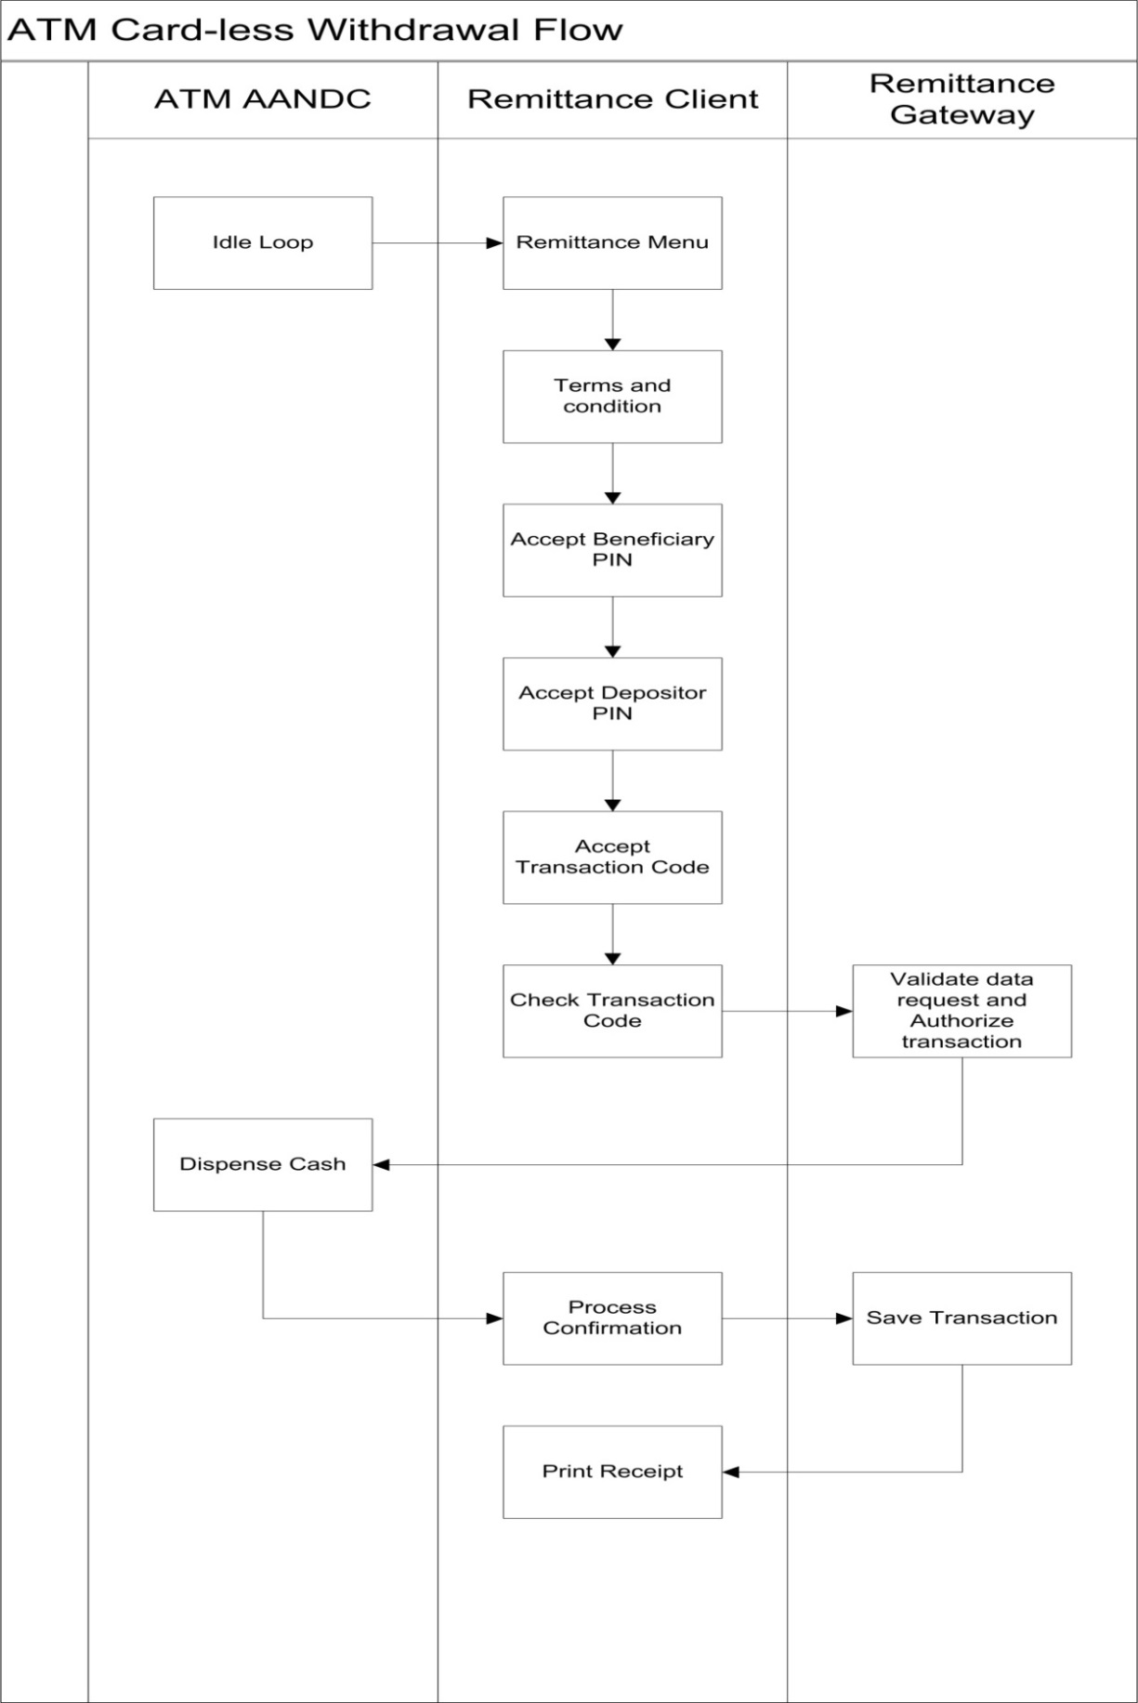

#### Withdrawal through branch

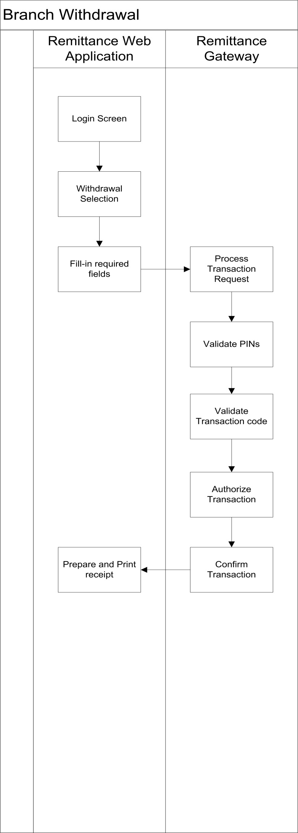

### 2.1.4 Redemption Flow

Redemption is a feature in the remittance system which allows the depositor to withdraw money previously deposited for a remittance transaction that has expired after a few set days.

#### Redemption through an ATM

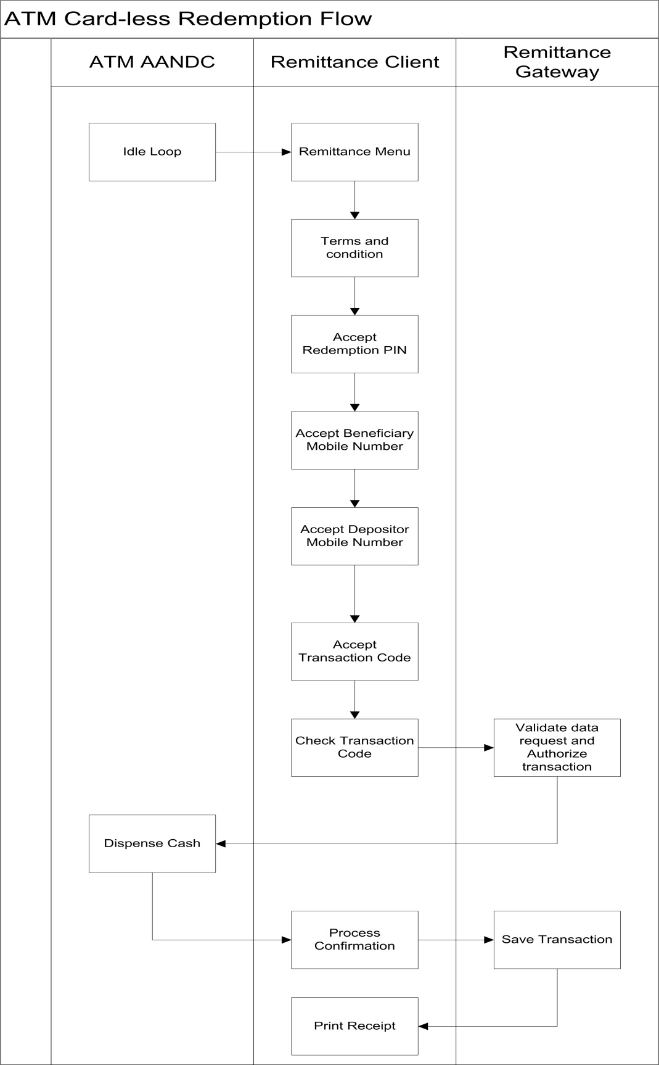

## 2.2 Card based to card less

### 2.2.1 Description

This flow allows the users to use their own existing personal bank account to transfer money from. When the customer enters his card, he will be given the option to utilize the remittance service which is directly linked to his account.

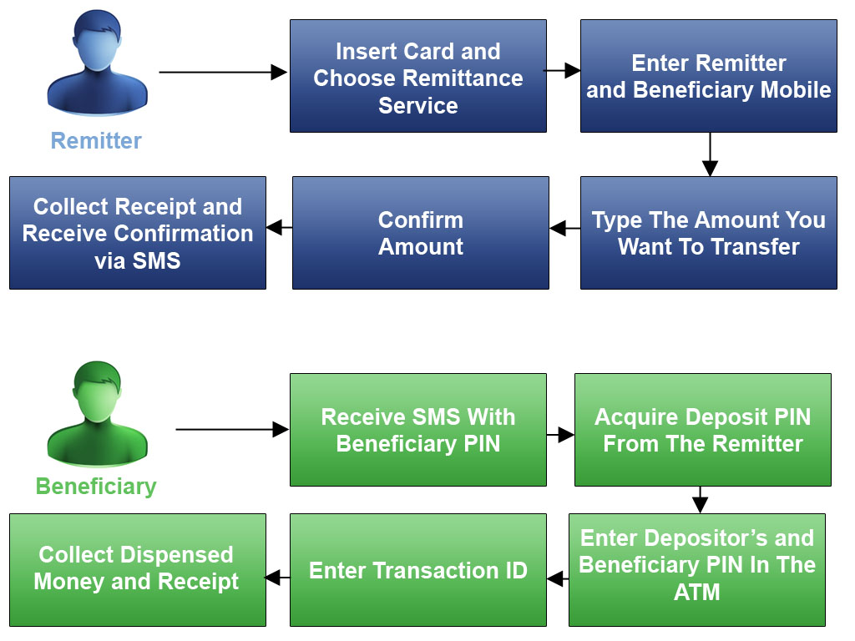

### 2.2.2 Flow

This transaction has a similar flow as card-less to card less; however, the depositor will not need to deposit any cash money given the fact that the money gets transferred directly from their bank account; however, the rest of the procedure remains the same.

# 3. Business Validations

1. Transaction Redemption
2. Transaction Holding Rule
3. Transaction Amount Rule
4. Daily Amount Rule
5. Monthly Amount Rule
6. Blocked Mobiles
7. Depositor Registration
8. Dispensability
9. Reactivation Rule
10. Transaction Expiration Rule
11. Key Trials Rule

# 4. Security Considerations

* All exchanged message are encrypted and signed (1024 bits key).
* All Keys are stored in an encrypted form inside System database.
* Keys expire after expiration period (configured).
* Reactivate expired transaction --- generates new keys.
* An overall checksum is calculated for all transactions.
* Dividing PIN code into two parts,
  + One with depositor (finally passed to beneficiary) and the other part with the beneficiary.
* Sending SMS’s through different mobile operators.

# 5. Settlement and Reconsolidation Process

* At the end of each business day, An End Of Day file is generated from the Cash Remittance server covering all the transactions in that day with the following format:

|  |  |
| --- | --- |
| **Field** | **Length** |
| Transaction Code | 12 |
| Terminal ID | 8 |
| Depositor Mobile | 15 |
| Beneficiary Mobile | 15 |
| Amount | 8 |
| Action Date | 8 |
| Action Time | 6 |
| Commission Amount | 8 |
| Action | 5 |
| Teller/ATM | 6 |
| Transaction Sequence Number | 10 |
| Dispensed Notes | 8 |

* The generated file is then processed by the bank system to affect the accounts of each terminal.

# 4. Web Portal Application

## 4.1 Description

This is a web application designed and created to give the bank a user friendly interface where they will be able to register users for the cash remittance service. It also has multiple functionalities including:

1. Reporting
2. Managing ATMs on the remittance service
3. Managing transactions
4. Managing users information
5. Maintenance

## 4.2 Functions

### 4.2.1 ATM Management

This allows the bank to add the ATM details to the system including the ATM number, ATM IP address and ATM name and location. This enables them to utilize and connect to the cash remittance service to process all transactions being committed. It also gives the option to edit previously added ATM details in case there was a mistake in the data entry.

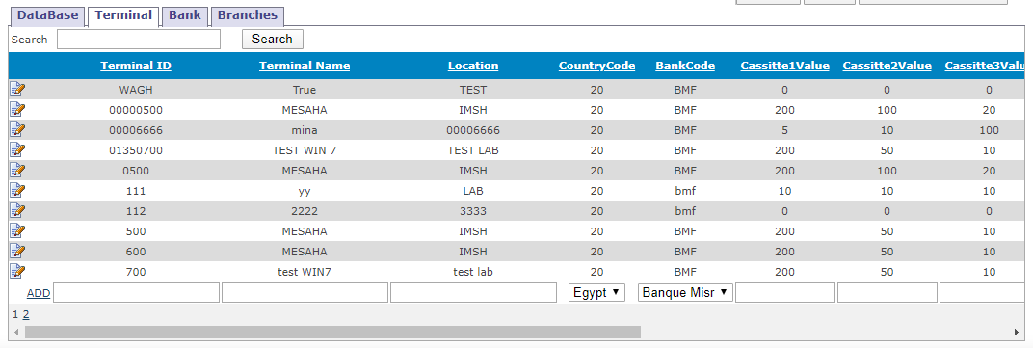

### 4.2.2 Transactions Handling

This allows the bank to specify any time span and check all the transactions initiated during that period of time including transactions that are completely processed and transactions that have been blocked or expired. After choosing any transaction, the user will get all details about the transaction including all the steps it took during its processing. The user can manually unblock or expire transactions through this feature which allows for more flexibility.

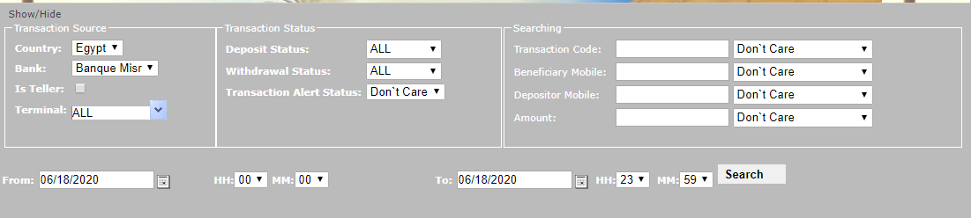

### 4.2.3 User Management

This allows the bank to manage the users for this portal and their privileges over it. The user privileges include transaction manager, report viewer and administration. Each user privilege is assigned to bank employees accordingly.

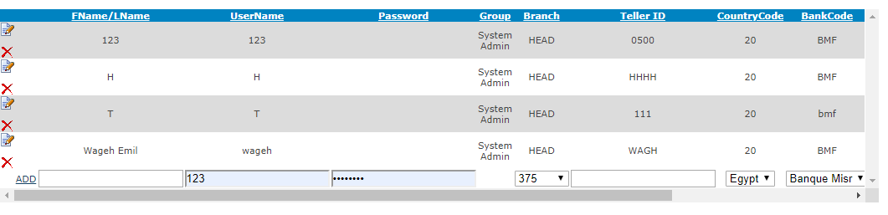

### 4.2.4 Customer Management

This allows the bank to manage all the remittance registered users. It allows them to add the user’s details including their name, address, mobile number and national ID number. The user cannot register into the system unless their national ID number is valid for extra security and integrity of the user. The bank can also edit previously added customer details in case of error.

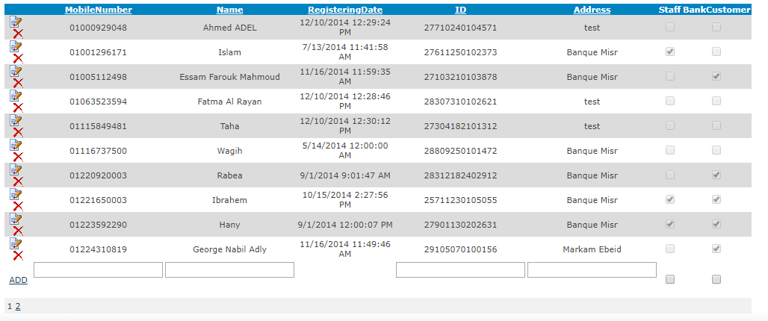

### 4.2.5 Reports

There are reports included in the portal that allows the bank to view data about the transaction initiated and committed during a specified time span. The user will be able to check transactions have been completed, transactions that expired, transactions that got blocked, total commission, total money transferred and other informative data. The user gets multiple filter options to make the search faster and easier including filtering by ATM number and mobile number. In the report page, the user will have the ability to customize how you want to view the report or choose from a set of ready-made reports.

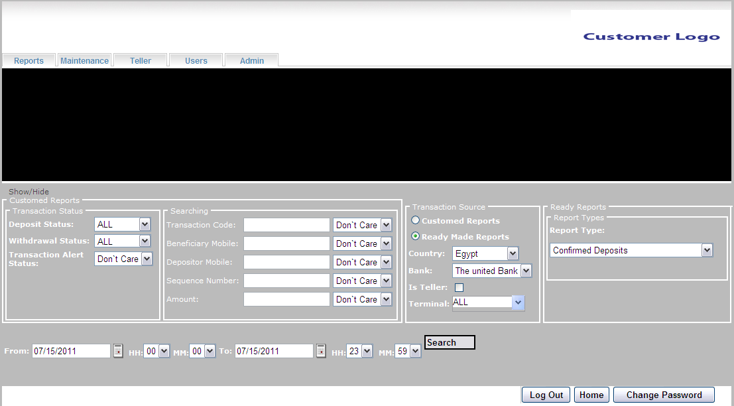

#### Custom Reports:

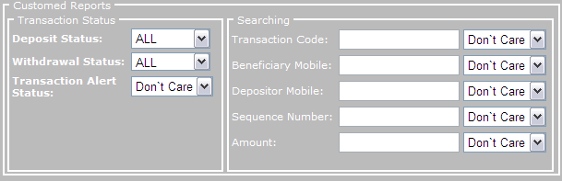

Custom reports group is used to make a report based on specific criteria which the user chooses. These criteria include:

1. Searching with the deposit status or with the withdrawal status. The status can be any of the following:
2. Authorized
3. Confirmed
4. Canceled
5. Expired
6. Held
7. All
8. Don’t Care
9. Searching with the transaction alert status, the status can be any of the following:
10. Don’t Care
11. Sent
12. Unsent
13. Searching with transaction ID, beneficiary mobile, depositor mobile, transaction sequence number and amount. To make the search more accurate the user will have the following criteria as a parameter for this filter:
14. Start With
15. Part Of
16. Ends With
17. Exact
18. Don’t Care

#### Ready reports:

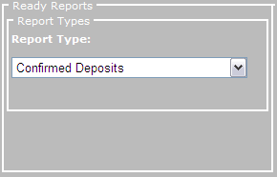

This is a set of predefined reports that can be used just by selecting the time interval that the report should cover.

The readymade reports include:

1. Confirmed deposits Reports.
2. Confirmed withdrawals Reports.
3. Confirmed redemptions Reports.
4. Expired transactions Reports.
5. Blocked transactions Reports.
6. Audit Reports.
7. Blocked depositors Reports.
8. Blocked beneficiaries Reports.

**Any other report can be integrated into the application.**

* **Transaction Source:**

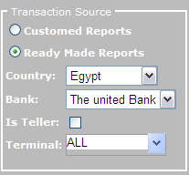This group controls the report source of transactions:

The (Is Teller) checkbox indicates whether the user is generating a report for terminals which is considered as Tellers, checking this checkbox will load the terminals combo box with all the tellers terminals

In the above group you can choose whether you want the costumed group or the readymade group, also the user choose the country, bank, and the terminal.

After choosing any from the criteria the user should choose a time frame that the report should cover.

### 4.2.6 Bulk Transactions Reports

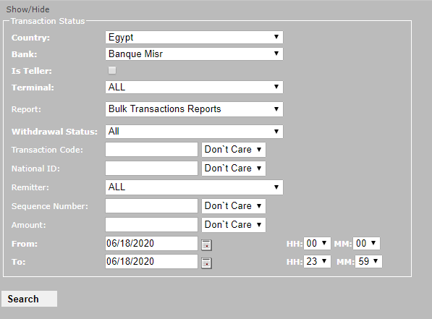

# 5. Alerting Service

## 5.1 Introduction

The Alerting service is the service which is responsible of sending the SMS to both transaction parties (depositor & beneficiary) according to transaction status. The service sends four different alerts for each transaction, two alerts are sent upon deposit success and the other two alerts are sent after withdrawal success. The Alerting service can use simple SMS modem for sending SMS alert or be integrated with any third party SMS gateway.

## 5.2 Architecture

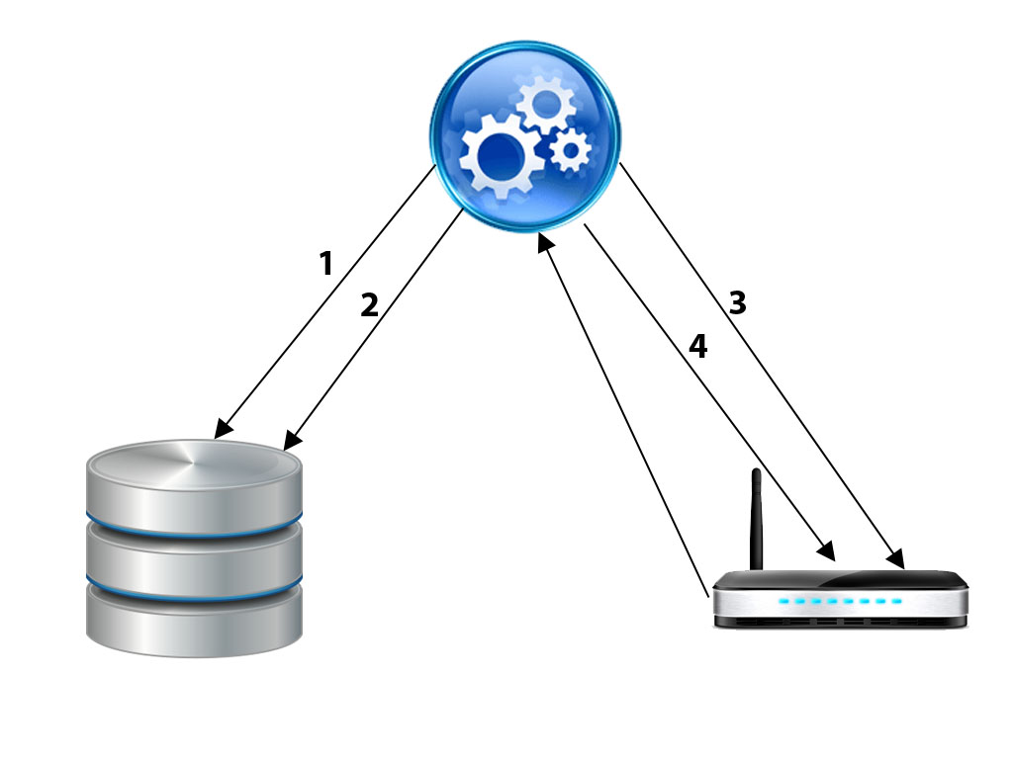

1. The service queries the database for transactions matching specific criteria.

2. The database returns the transaction details to the service.

3. The service starts sending transactions details to its respective customers.

4. The service checks for the reports of the sent transactions so it can assure the delivery of the sent messages.

## 5.3 Functionality

1. The alerting service sends messages when:
   1. The depositor deposits the money.
   2. The beneficiary withdrawals the money.
   3. The depositor and the beneficiary after successful transaction.
2. The service sends 2 messages at a time to both the depositor and the beneficiary.
3. Checking for the delivery reports in the modem for the sent transactions.

## 5.4 Alerting Service Main Points

1. **Developing such service can be done by multiple methods including:**

* Service provider gateway where no development is done in the SMS part.
* A URL where you use a specific URL while adding some parameters (To, Message content…..).
* Database.

-Where you store the SMS you want to send in a specific table and it will be sent automatically.

* Through Modem.

-You would have to develop everything in the SMS part (connection, configuration, sending, tracking delivery reports, decoding PDU format……).

1. **Third party libraries:**

*GSMComm* is a library that gives us a helping hand when working with SMS related task. It also supports 7-bit default alphabet and Unicode for the message text (Arabic, Hebrew…).

1. **Reading Reports Process**:

In order to keep track of the reports we faced some issues. One of these issues was the modem. The modem keeps a reference number for each SMS it sent. The problem here is that the modem can count only from 0 to 255 then it starts all over again from 0. This essentially will create duplicate rows and creates a dilemma in identifying the report with the mobile number.

To overcome this problem we had to be sure that the modem will not send a SMS to a mobile number with the same reference number where this stored SMS must be undelivered.

## 5.5 SMS Contents

The following examples are samples of how the SMS sent to both the depositor and the beneficiary clients look like.

### 5.5.1 Deposit

**Depositor Message:**

Dear Customer You Have Sent

Amount: ______

To: ______

TransactionCode: ________

Pin#1: ____

The Beneficiary should get you pin.

**Beneficiary Message:**

Dear Customer You Have Received

Amount:

From:

TransactionCode:

Pin#2:

The depositor has pin#1

Get your amount at any NCR ATM.

### 5.5.2 Withdrawal

**Depositor Message:**

Dear Customer

Beneficiary: ________ Withdrawn

Amount: ____

TransactionCode: _____

Pin#1:______

Thank You for Using NCR Money Transfer Service.

**Beneficiary Message:**

Dear Customer you have withdrawn

Amount: ____

From: ______

TransactionCode: _________

Pin#2:____

Thank You for Using NCR Money Transfer Service.

# 6. Hardware Requirements

The following list is the recommended hardware and software configuration in order to run the solution. The proposed hardware specification depends on variables such as transaction volume, maximum concurrent users and typical data record sizes that will be carefully considered before implementation. The final specification will be determined during system design whereby detail sizing will be performed.

## 6.1 Application Sever/Database Server/Gateway

### 6.1.1 Production Environment

|  |  |  |  |
| --- | --- | --- | --- |
| Server | Hardware Configuration | Software configuration | Remark |
| Web/Application Server | * 4 Core Processor * 4GB RAM * 100GB HDD * Dual Ethernet NIC | * Windows 2008 R2 Standard Edition Server x64 * IIS 7.5 |  |
| Database Server | * 4 Core Processor * 6-8 GB RAM * 200GB HDD * Dual Ethernet NIC | * Windows 2008 R2 Standard Edition Server x64 * MS SQL 2008 R2 Enterprise Edition | An existing MS SQL server environment can be used. |

### 6.1.2 Testing Environment

|  |  |  |  |
| --- | --- | --- | --- |
| Server | Hardware Configuration | Software configuration | Remark |
| Single server for Application+ Database for Testing environment | * 2 Core Processor * 4GB RAM * 50GB HDD * Dual Ethernet NIC | * Windows 2008 R2 Standard Edition Server x64 * IIS 7.5 * MS SQL 2008 R2 | An existing MS SQL server environment can be used. |

## 6.2 ATM

### 6.2.1 Hardware Requirements

To enable cash deposit on the ATM, a cash deposit device is required. BNA or GBNA can be used under AANDC control and management. Other H/W figures are the same as AANDC system needs.

### 6.2.2 Software Requirements

Beside software requirements for AANDC the MS DOTNET 2.0 is required for the client.

# 7. System Architecture

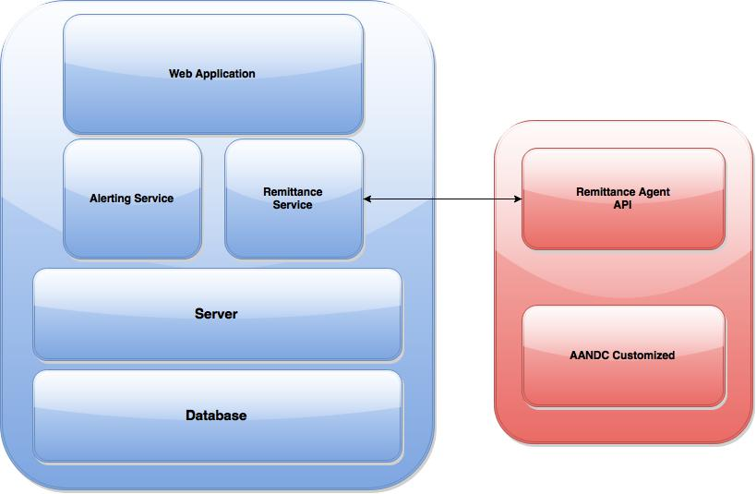

# 8. Financial Proposal